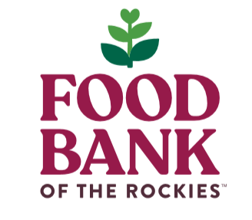
Partner Update Form
Please use this form to notify us of any changes to your program!

Please check the boxes for each Food Bank of the Rockies program you participate in.

Program Support TEFAP Everyday Eats Food for Kids Food Rescue

(Totes, CACFP, SFSP)

Program Name: | Agency Express Program Code:
Mailing/Billing address: | Food Storage address, if different:
City, State, Zip: | City, State, Zip:
Director: | Main Contact:
Director Phone: | Main Contact Phone:
Director Email: | Main Contact Email:
Billing Contact: | Date & Hours of Distribution:
Billing Contact Phone: | Additional Email to just Receive Monthly Billing Statements:
Billing Contact Email: | Additional Email(s) to just Receive Monthly Partner Newsletters & E-Blasts:

I hereby certify that the information above is accurate:

Signature of Main Program Contact Date
Email, Fax or Mail completed form to:
PartnerSolutions@FoodbankRockies.org
Food Bank of the Rockies Attn: Partner Solutions
10700 E. 45th Ave
Denver, CO 80239
Fax: 303-574-0622

Partner Shopper Update
Please list up to four (4) authorized shoppers. There must be one (1) authorized shopper present to sign invoices for order pickup.

Program Name/Agency Express Program Code:

____________________________________________________

Remove Shoppers | Add Shoppers  Any shoppers NOT listed will be removed
Name:  _____________________________________ | Shopper 1:  Name: _______________________________  Email: ________________________________  Phone # ______________________________  Pick-Up order/FFC AE Online Shopper Both
Name:  _____________________________________ | Shopper 2:  Name: _______________________________  Email: ________________________________  Phone# _______________________________  Pick-Up order/FFC AE Online Shopper Both
Name:  _____________________________________ | Shopper 3:  Name: _______________________________  Email: ________________________________  Phone # _______________________________  Pick-Up order/FFC AE Online Shopper Both
Name:  ____________________________________ | Shopper 4:  Name: _______________________________  Email: _______________________________  Phone #______________________________  Pick-Up order/FFC AE Online Shopper Both

I hereby certify that the information above is accurate. I also guarantee that all authorized shoppers have attended orientation or will RSVP to an upcoming orientation.
Email, Fax or mail completed form to:
PartnerSolutions@FoodbankRockies.org
Food Bank of the Rockies Attn: Partner Solutions
10700 E. 45th Ave
Denver, CO 80239
Fax: 303-574-0622

__________________________________________ __ ____________
Signature of Primary Program Contact Date

